**COMPUTER ORGANIZATION AND ASSEMBLY LANGUAGE**

**LAB TASK 06**

Aliza Rizvi

58782

**TASK 1**

Write a program in assembly language to print your CV or Biodata

**Code:**

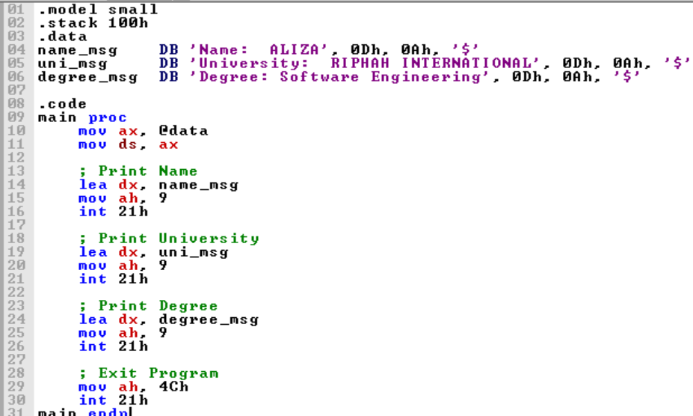

**Output:**

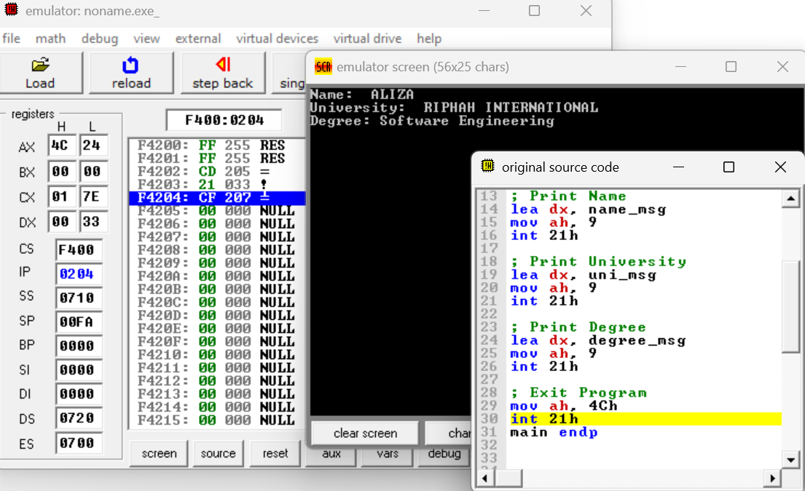

**TASK 2**

Write a program that input a character from user and print that again on screen in the given format.

**Code:**

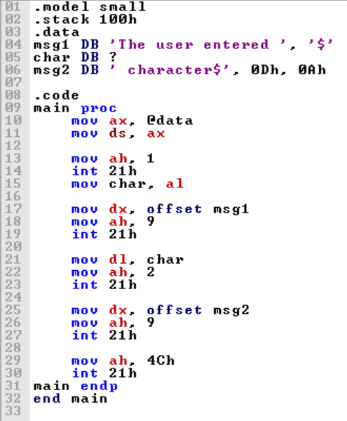

**Output:**

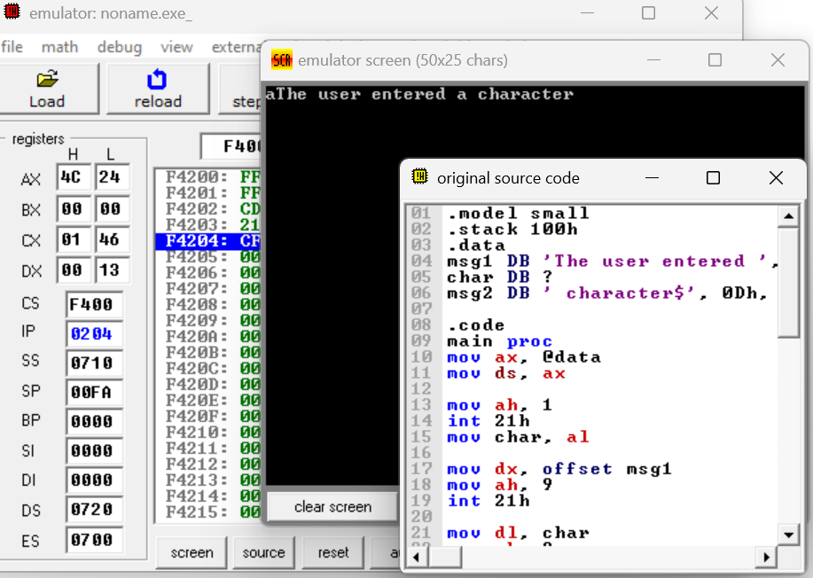

**TASK 3**

Write a program that input a character from user is in lowercase, the program will convert it to uppercase and will display it on console after conversion. Show messages stored in variable strings to the user.

**Code:**

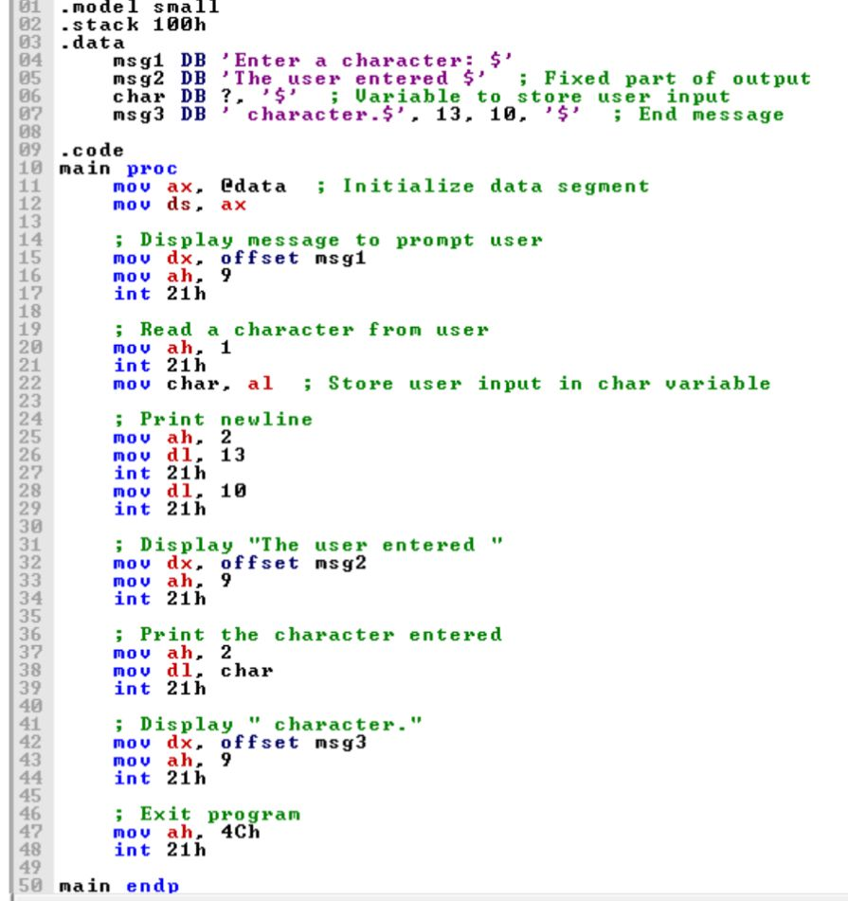

**Output:**

